

**Day 6: Heritage Trail in Ahmedabad**

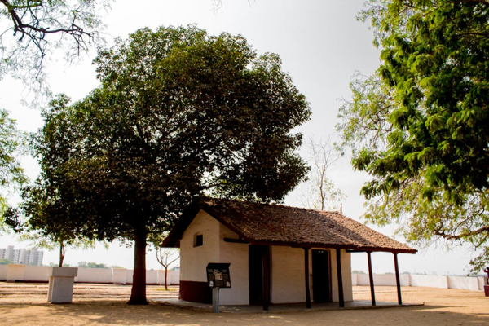

Travel Time: 6 hours  
Travel Distance: 200 km  
We will travel to Ahmedabad, the cultural capital of Gujarat. Here, we will visit Sabarmati Ashram, Jama Masjid, Adalaj Stepwell, and Akshardham Temple. We can also indulge in shopping at Law Garden Market for traditional handicrafts.